20BCE1837

EX No. 6

Lab - 9

1. Write a PHP program to write 100 integers in to a text file. Read 10 numbers at a time from the file using PHP script and find the numbers which occurs odd number of times.

Sample Input : 4, 5, 4, 5, 2, 2, 3, 3, 2, 4

Output : 2, 4 9.

**Code:**

**1.**

# php

<?php

$file = fopen("num.txt", "w"); ftruncate($file, 0);

for($i=0; $i<100;$i++){

$num = rand(1,20)."\n"; fwrite($file, $num);

}

fclose($file);

$file = file('num.txt');

$c=0;

$arr = array(); foreach($file as $line) {

$num = $line; if((array_key_exists($num, $arr))){

$arr[$num]++;

}

else{

$arr[$num] = 1;

}

$c++;

if($c%10 == 0){

foreach($arr as $a => $b){ if($b%2!=0)

echo $a." ";

}

echo "<br>"; unset($arr);

$arr = array();

}

}

?>

# Output

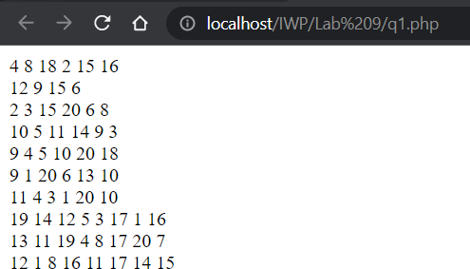

1. Implement simple currency calculator utility-program, which can be used to calculate currency conversions from dollars to euros. Exchange rates can be found for example on <http://www.x-rates.com/d/EUR/table.html>. Implement simple HTML- form where user user can input amount of dollars (currency.html) and PHP-script (calculate.php) to calculate currency conversion. PHP-script will read the input values from HTML-form and perform conversion by multiplying dollars with current exchange rate.

|  |  |
| --- | --- |
| Description: http://www.oamk.fi/~jjuntune/php/pictures/exercise1a.jpg | Description: http://www.oamk.fi/~jjuntune/php/pictures/exercise1b.jpg |

# currency.html

<!DOCTYPE html>

<html lang="en">

<head>

<meta charset="UTF-8">

<meta http-equiv="X-UA-Compatible" content="IE=edge">

<meta name="viewport" content="width=device-width, initial- scale=1.0">

<title>Q2</title>

</head>

<body>

<h2>Currency Calculator</h2>

<form action="calculate.php" method="post">

<div class="main">

<label for="cur">Dollars:</label>

<input type="text" name="cur" id="cur"><br>

<br>

<button type="submit" name="submit">Calculate</button>

<button type="submit" name="reset">Reset</button>

</div>

</form>

<br>

</body>

</html>

# calculate.php

<?php

$d = $eu = 0; if($_SERVER['REQUEST_METHOD']=="POST"){

if(isset($_POST['submit']) && !empty(trim($_POST['cur'])) && is_numeric(trim($_POST['cur']))){

$d = trim($_POST['cur']);

$eu = $d*1.02;

$f = 1;

}

else{

header('Location: ./currency.html');

}

}

?>

<!DOCTYPE html>

<html lang="en">

<head>

<meta charset="UTF-8">

<meta http-equiv="X-UA-Compatible" content="IE=edge">

<meta name="viewport" content="width=device-width, initial- scale=1.0">

<title>Q2</title>

</head>

<body>

<h2>Currency Calculator</h2>

<?php echo "$d Dollars = $eu Euros";?>

<br><br>

<a href="./currency.html">Back to Calculator</a>

</body>

</html>

# Output

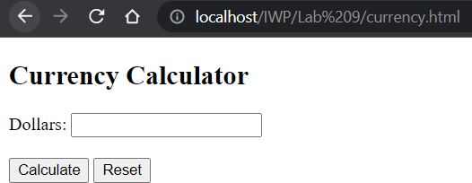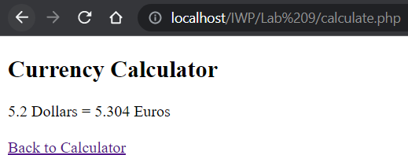

1. Implement simple application that can be used to sent emails. Use email- function.

<?php

$email = $sub = $msg = ""; if($_SERVER['REQUEST_METHOD']=="POST"){

$email = trim($_POST['email']);

$sub = trim($_POST['subject']);

$msg = trim($_POST['msg']); if(isset($_POST['send']) && filter_var($email,

FILTER_VALIDATE_EMAIL) && !empty($msg)){ mail($email, $sub, $msg);

}

else{

echo “Failed”;

}

}

?>

<!DOCTYPE html>

<html lang="en">

<head>

<meta charset="UTF-8">

<meta http-equiv="X-UA-Compatible" content="IE=edge">

<meta name="viewport" content="width=device-width, initial- scale=1.0">

<title>q3</title>

</head>

<body>

<form action="" method="post">

<label for="email">Receiver Email:</label><br>

<input type="email" name="email"><br><br>

<label for="subject">Subject:</label><br>

<input type="text" name="subject"><br><br>

<label for="msg">Message:</label><br>

<textarea name="msg" cols="30" rows="10"></textarea><br><br>

<button type="submit" name="send">Send</button>

</form>

</body>

</html>

# Output

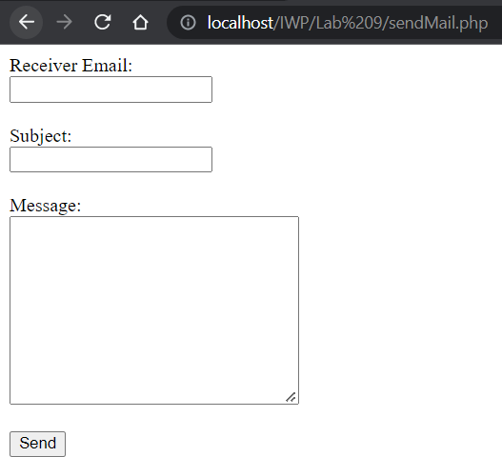

1. Implement application, which can be used to calculate housing allowance for student. Housing allowance is 80% of reasonable housing cost. Reasonable housing cost is between 33.64�252 �. if cost is under 33.64 � no allowance is paid. If cost is over 252 �, maximun allowance 201.60 � is paid. If cost is between 33.64 � and 252�, allowance is 80%.

<?php

$a = $cost = ""; if($_SERVER['REQUEST_METHOD']=="POST"){

if(isset($_POST['check']) && !empty(trim($_POST['cost'])) && is_numeric(trim($_POST['cost']))){

$cost = trim($_POST['cost']); if($cost<33.64)

$a = 0;

else if($cost<252)

$a = 0.8*$cost; else

$a = 201.60;

}

}

?>

<!DOCTYPE html>

<html lang="en">

<head>

<meta charset="UTF-8">

<meta http-equiv="X-UA-Compatible" content="IE=edge">

<meta name="viewport" content="width=device-width, initial- scale=1.0">

<title>q3</title>

</head>

<body>

<h2>Housing Allowance Calculator</h2>

<form action="" method="post">

<label for="cost">Housing Cost: </label>

<input type="text" name="cost" value=<?php echo $cost?>>

<button type="submit" name="check">Check</button>

<br><br>

<label for="allowance">Allowance: </label>

<input readonly type="text" value=<?php echo $a?>>

</form>

</body>

</html>

# Output

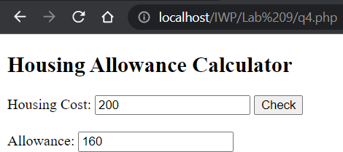

1. Implement PHP ml is needed) to print out multiplication table of number 10 (see picture below). User for-structure and table html-element.

<?php

$disp = "<table>"; for($i=1; $i<=10; $i++){

$p = $i*10;

$disp .= "<tr><td>$i * 10 = $p</td></tr>";

}

$disp .= "</table>"; echo $disp;

?>

<style> td{

border: 1px solid black;

}

</style>

# Output

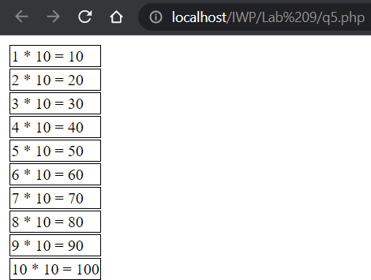

1. 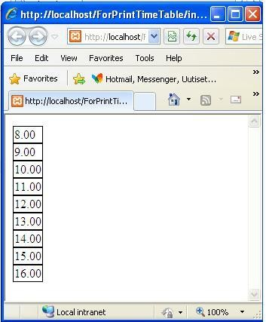Implement PHP-script to print out times from 8 to 16 to HTML-table.

<?php

$disp = "<table>"; for($i=8; $i<=16; $i++){

$p = number_format((float)$i, 2, '.', '');

$disp .= "<tr><td>$p</td></tr>";

}

$disp .= "</table>"; echo $disp;

?>

<style> td{

border: 1px solid black;

}

</style>

# Output

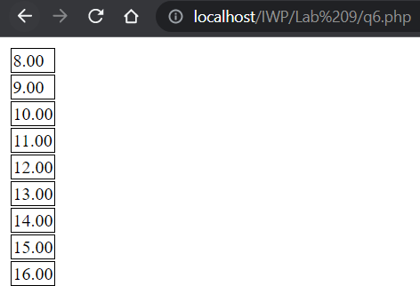

1. Modify previous exercise so that also day of weeks are printed to page necessary amounts of columns are printed out to each row. Use conditional and loop -structures to implement exercise.

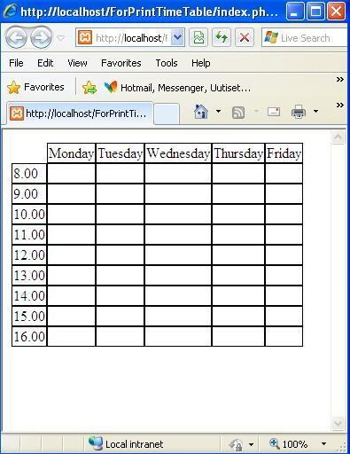

<?php

$disp = "<table>";

$d = array(" ", "Monday", "Tuesday", "Wednesday", "Thursday", "Friday", "Saturday", "Sunday");

for($i=0; $i<=8; $i++){

$disp .= "<tr>"; for($j=0; $j<=7; $j++){

if($i==0){

$disp .= "<td>".$d[$j]."</td>";

}

else if($j==0){

$p = number_format((float)($i+7), 2, '.', '');

$disp .= "<td>$p</td>";

}

else{

$disp .= "<td> </td>";

}

}

$disp .= "</tr>";

}

$disp .= "</table>"; echo $disp;

?>

<style> td{

border: 1px solid black;

}

</style>

# Output

